CANADIAN COLLEGE OF MODERN TECHNOLOGY

1 Silicon Hill

Mile 91

ASSIGNMENT ONE

**NAME:** HENRY MARRAH

**ID NO:** 19290308

**DEPARTMENT**: COMPUTER SCIENCE

**LEVEL:** YEAR THREE, SEMESTER ONE

**MODULE:** SOFTWARE ENGINEERING

**LECTURER:** MR HAMID MILTON MANSARAY

**DATE OF SUBMISSION:** 15TH FEBRUARY, 2021.

**THE FIVE (5) SOFTWARE DEVELOPMENT METHODOLOGIES USED IN SOFTWARE DEVELOPMENT. PHASES/STAGES, ADVANTAGES AND DISADVANTAGES OF THESE METHODOLOGIES**

**ACKNOWLEDGEMENT**

This individual assignment would not have been possible without the help of several persons. First of all, I would like to thank my college (CCMTSL) for providing me internet facilities and my honorable lecturer Mr Hamid Milton Mansaray. I could not have had any better work than you. You have given me a lot of support and time, and showed great interest in my work. I would also like to thank the other participants of the individual assignment, all my friends for being great co-workers in their work also. Again, I would also like to thank my family for supporting me with financial aid to continue with my course. Lastly, I thank Allah for his grace for giving me the energy to do this work.

**TABLE OF CONTENT**

**TOPICS** **PAGE NO:**

1. Introduction………………………………………………………………………….. 4.
2. Agile Software Development Methodology………………………………4,5
3. Phases/Stages of Agile Software Development Methodology……5,6

3.1 Advantages and Disadvantages of Agile Development Methodology……………………………………………………………………………………6,7

4.0 Waterfall Model Development Methodology…………………………………7

4.1 Phases/Stages of Waterfall Model Development Methodology………,7,8

4.2 Advantages and Disadvantages of Waterfall Model Development…8,9

5.0 Joint Application Development Methodology……………………………….9

5.1 Phases/Stages of Joint Application Development (JAD)………………..9

5.2 Advantages and Disadvantages of (JAD)……………………………………..9,10

6.0 Rapid Application Development (RAD)………………………………………10

6.1 Phases/Stages of Rapid Application Development (RAD)……………10

6.2 Advantages and Disadvantages of (RAD)…………………………………….10,11

7.0 Extreme Programming Methodology…………………………………………12,13

7.1 Phase/Stages of Extreme Programming Methodology………………..13

7.2 Advantages and Disadvantages of **EP** Methodology…………………….13

8.0 Conclusion and References……………………………………………………….14,15

**INTRODUCTION**

**Software development methodologies** play a dynamic part of developing the software. There are many methodologies which are used by the professional software development companies nowadays. We have certain advantages and disadvantages related to each of them. The main purpose of these methodologies is to provide smooth software development according to the project requirements. Software development methodology is a framework that is used to structure, plan, and control the process of developing an information system. This kind of development methodologies are only related to the software development process, so it does not involve any technical aspect, but only concern with proper planning for the software development.

BELOW ARE THE 5 SOFTWARE DEVELOPMENT METHODOLOGIES USED IN SOFTWARE DEVELOPMENT WITH THEIR PHASES/STAGES, ADVANTAGES AND THEIR DISADVANTAGES

1. Agile Software Development Methodology

2. Waterfall Model Development Methodology

3. Joint Application Development (JAD)

4. Rapid Application Development (RAD)

5. Extreme Programming Methodology etc.

**1. Agile Software Development Methodology:** This is an approach that is used to design a disciplined software management process which also allows some frequent alteration in the development project. This is a type of software development methodology that is one conceptual structure for undertaking various software engineering projects.

**Phases/Stages of Agile Software Development Methodology**

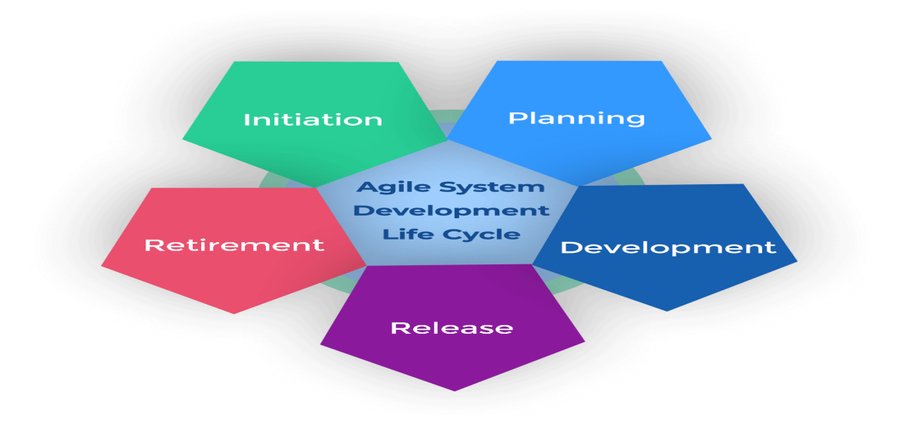

1. **Project Initiation**: This is the first phase in the life cycle of agile software development. Normally referred to as the inception or the beginning phase, this stating stage is about discussing the project vision and the ROI justification. During this step, you should identify team members and determine the time and work resources are required to complete the project.

2. Planning phase: The planning phase is where the team gets together with their sponsor or product owner and identifies exactly what they are looking for. They discuss how this will be made possible by building the backlog at the story level.

3. Development phase: Once the requirements have been defined based on feedback from the product owners and stakeholders, the actual work begins.

4. Production phase: Here your product has now been deployed and is being used by final end-users. It is important to closely monitor these early stages for bugs or defects missed in testing. A handover with relevant training should take place between the production and support teams.

5. Retirement phase: This is the final stage of the Agile lifecycle. The product is now at the ‘end of life’ stage and will be pulled from production and decommissioned (sometimes referred to as ‘sunsetting’). Customers are notified and informed about migration to newer releases or alternative options.

**Advantages of Agile Development Methodology:**

* Customer satisfaction by rapid, continuous delivery of useful software.
* People and interactions are emphasized rather than process and tools. Customers, developers and testers constantly interact with each other.
* Agile methodology has an adaptive approach that is able to respond to the changing requirements of the clients.

**Disadvantages of Agile Development Methodology:**

* In the case of some software deliverables, especially the large ones, it is difficult to assess the effort required at the beginning of the software development life cycle.
* This methodology focuses on working software rather than documentation, hence it may result in a lack of documentation.
* The project can easily get taken off track if the customer representative is not clear what final outcome that they want.

**2. Waterfall Model Development Methodology:** is one of the most traditional and commonly used software development methodologies. Most businesses consider this model as a classic style of software development. This model clarifies the software development process in a linear sequential flow. In any phase of the development cycle, you should always cross-check that the earlier phase is completed.

**Phases/Stages of Waterfall Model Development Methodology**

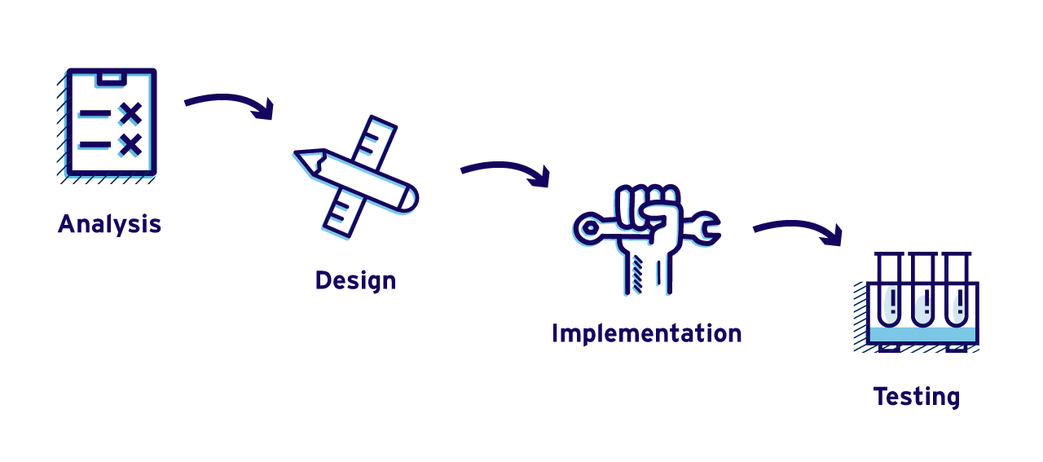

Analysis phase: Here the product development team analyzes the requirements, and fully understands the problems. This is a research phase that includes no building.

Design phase: The software developers design a technical solution to the problems set out by the product requirements, including scenarios, layouts and data models. This phase is usually accompanied by documentation for each requirement, which enables other members of the team to review it for validation.

Implementation phase: In this phase once the design is approved, technical implementation begins. These show the shortest phase because research and design have been done in advance.

Testing phase: Upon completion of full implementation, testing needs to occur before the product can be released to customers. The software testing team will use the design documents, personas and user case scenarios delivered by the product manager in order to create their test cases.

**Advantages of the Waterfall Model:**

* Waterfall model is very simple and easy to understand and uses methodology. That is why it is beneficial for the beginner or novice developer.
* It is easy to manage the projects because of the rigidity of the model. Moreover, each phase has specific deliverables and an individual review process.
* This model saves a significant amount of time at all the phases processed and completed at a given time.

**Disadvantages of Waterfall Model:**

* This model is not applicable to projects that demand continuous maintenance.
* In this model, there is no option to know the end result of the entire project
* In this model, Documentation occupies a lot of time for developers and testers.

**3. Joint Application Development (JAD):** Is a requirements-definition and user-interface development methodology in which end-users, clients, and developers attend intense off-site meetings to work out and finalize software system. This methodology aims to involve the client in the design and development of an application.

**Phases/Stages of Joint Application Development (JAD)**

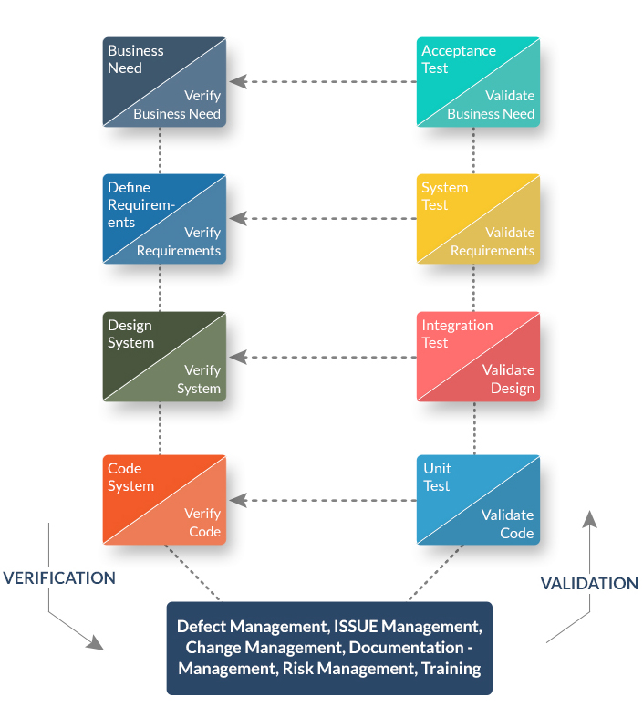

**Advantages of JAD Methodology**

* This model provides a forum to explore multiple points of view regarding a topic.
* Well-defined requirements improve system quality.
* With the proper assistance of the organizer, the differences are immediately resolved in this method

**Disadvantages of JAD Methodology:**

* JAD methodology takes a large amount of time as it requires significant planning and scheduling effort on the part of the project development team.
* It requires significant investor commitment in terms of time and effort..
* Different opinions within the team make it difficult to align goals and maintain focus.

**4. Rapid Application Development (RAD):** is an active methodology that offers much quicker development and higher-quality results than those achieved with the other software development methodologies. It is designed in such a way that it easily takes the maximum advantage of the software development.

**Phases/Stages of Rapid Application Development (RAD)**

[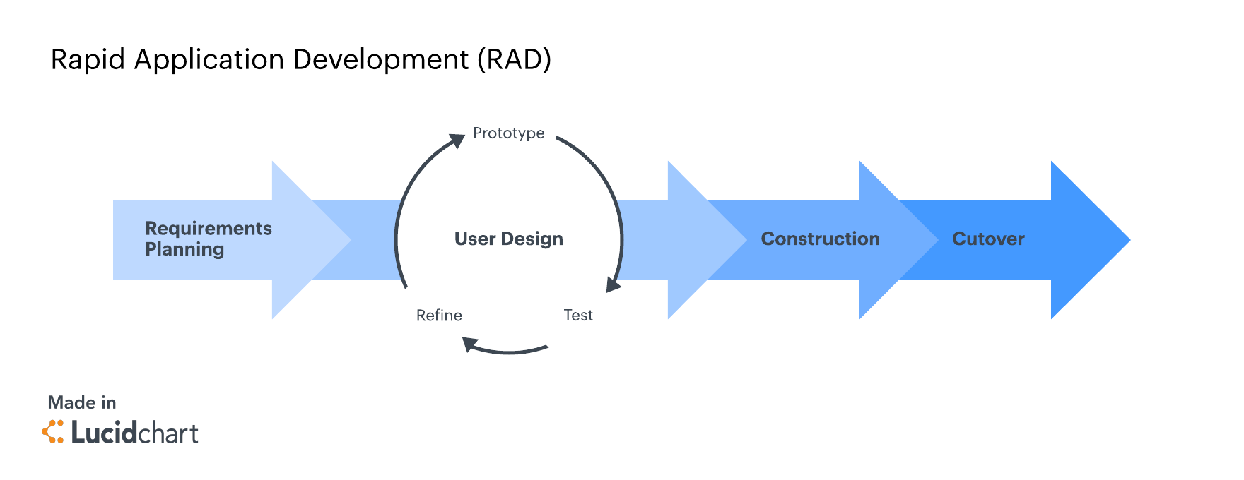](https://www.lucidchart.com/documents/editNewOrRegister/ebe94c8f-f5be-4a56-927b-8ff94384c3ba)

1. Requirements planning:This phase is correspondent to a project scoping gathering. Although the planning phase is condensed compared to other project management methodologies, this is a critical step for the ultimate success of the project.

2. User design:Once the project is scoped out, it’s time to jump right into development, building out the user design through various prototype iterations.

3. Rapid construction:Phase 3 takes the prototypes and beta systems from the design phase and converts them into the working model.

4. Cutover**:** This is the implementation phase where the finished product goes to launch. It includes data conversion, testing, and changeover to the new system, as well as user training.

**Advantages of the RAD model:**

* Rapid Application development model helps to reduce the risk and required efforts on the part of the software developer.
* Additionally, this model also helps the clients to take quick reviews for the project.
* Each phase in RAD delivers the highest priority functionality to the client.

**Disadvantages RAD model:**

* This model depends on the strong team and individual performances for clearly identifying the exact requirement of the business.
* It only works on systems that can be modularized can be built using this methodology.
* This approach demands highly skilled developers and a designer’s team which may not be possible for every organization.

**5.** **Extreme Programming Methodology:** is an agile software engineering methodology. This methodology is mainly used for creating software within a very unstable environment. It allows greater flexibility within the modeling process. The main goal of this XP model is to lower the cost of software requirements. It is quite common in the XP model that the cost of changing the requirements on later stage in the project can be very high.

**Phase/Stages of Extreme Programming Methodology**

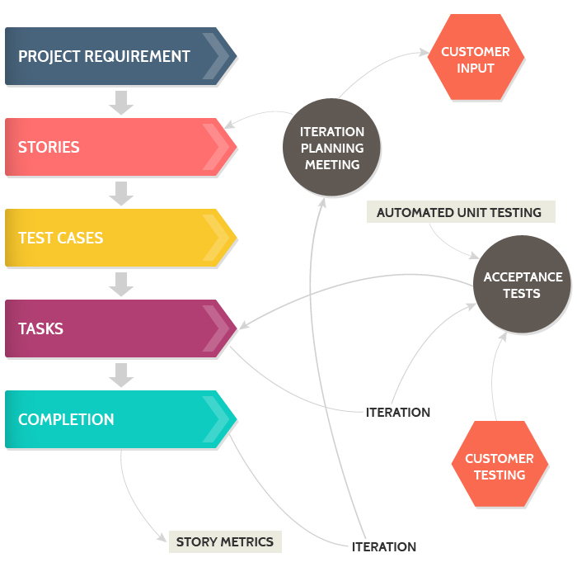

**Advantages of Extreme Programming Methodology**

• Extreme programming methodologies emphasis on customer involvement

• This model helps to establish rational plans and schedules and to get the developers personally committed to their schedules which are surely a big advantage in the XP model.etc

**Disadvantages of Extreme Programming Methodology**

• This methodology is only as effective as the people involved, Agile does not solve this issue

• This kind of software development model requires meetings at frequent intervals at enormous expense to customers.etc

**CONCLUSION**

The above software development methodologies are very important which are mostly used for various software development projects. Moreover, all these methodologies work well in certain projects depending upon the nature of the project. It often happens that one methodology that is suited for a particular project may not be suited for another project. Moreover, none of these methodologies are foolproof as each has its pros and cons. So, software developers must have information about all these methodologies before selecting any of these development methods for their software development projects. For better results, it is advisable to consult a professional software development comp

**References**

1. <https://www.tatvasoft.com/blog/top-12-software-development-methodologies-and-its-advantages-disadvantages/>

2. https://medium.com/brightwork-collaborative-project-management-blog/5-stages-of-the-agile-system-development-life-cycle-brightwork-com-a207bdf61696

3. Lübke, Daniel; van Lessen, Tammo (2016). "Modeling Test Cases in BPMN for Behavior-Driven Development". IEEE Software. 33 (5): 15–21

4. Whitten, Jeffrey L.; Lonnie D. Bentley, Kevin C. Dittman. (2003). Systems Analysis and Design Methods. 6th edition. ISBN 0-256-19906-X.

5. <https://learn.marsdd.com/article/product-development-the-waterfall-methodology-model-in-software-development/#:~:text=The%20Waterfall%20methodology%E2%80%94also%20known,design%2C%20development%2C%20testing>).

5. <https://www.lucidchart.com/blog/rapid-application-development-methodology> etc.